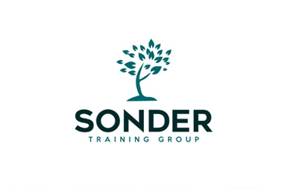
Level 6 Diploma in Careers Guidance & Development
Training Programme September 2026 – 2027

Content and Training Mode | Dates and Times
Induction and Overview  2 hours online workshop | Weds 16th September 2026  10am – 12 noon
Unit 1: Preparing to Work in the Career Development Sector  2 ½ hours online workshop | Weds 23rd September 2026  9:30am – 12 noon
Unit 3: Careers Guidance Theories and Models  3 x 3 hours online workshops | Weds 11th November 2026  9.30 am – 12.30 pm  Weds 18th November 2026  9.30am – 12.30pm  Weds 25th November 2026  9.30am – 12.30pm
Units 4 & 5: Individual Career Consultations  3 x 3 hours online workshops  Optional Full Day Masterclass - face to face | Weds 20th January 2027  9.30am – 12.30pm  Weds 27th January 2027  9.30am – 12.30pm  Weds 3rd February 2027  9.30am – 12.30pm  TBC  Date & Venue to be confirmed with candidates (later in the programme)
Unit 2: Reflect on and Improve Professional Practice  1 x 2 ½ hour online workshop | Weds 17th March 2027  9.30am –12 noon
Unit 6: Use Career Related Information with Clients  Unit 9: Source Evaluate and Use LMI with Clients  1 x 2 ½ hour online workshop and 1 hour support session | Weds 19th May 2027  9:30am – 12 noon  Weds 26th May 2027  9:30am – 10:30am
Unit 7: Work with Other Agencies for the Benefit of Clients and the Organisation  2 x 2 ½ hour online workshops | Weds 16th June 2027  9:30am – 12 noon  Weds 23rd June 2027  9:30am – 12 noon
Unit 10: Understand how to Support Specific Client Groups to Overcome Barriers to Learning, Training and Work | Independent Study Workbook
Unit 12: Assist Clients to Apply for Learning Training and Work | Independent Study Workbook
Completion Date | December 2027

Please Note - we currently offer 2 Pathways
Pathway A is above and includes Mandatory Units 1-7 and Optional Units 9/10 & 12
Pathway B includes Mandatory Units 1-7 and Optional Units 8 & 10 (Unit 8 - Use Diagnostic and Assessment Tools with Clients is undertaken by independent study)
These options can be discussed with your assessor when you meet for a professional discussion which is part of Unit 1

