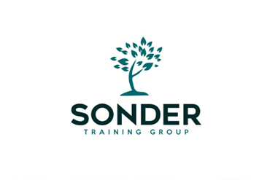

Level 6 Diploma in Careers Guidance & Development
Training Programme February 2026 – 2027

Content and Training Mode | Dates and Times
Induction and Overview  2 hours online workshop | Wed 25th February 2026  10am – 12 noon
Unit 1: Preparing to Work in the Career Development Sector  2hrs 30 mins online workshop | Wed 11th March 2026  9.30am – 12 noon
Unit 3: Careers Guidance Theories and Models  3 x 3 hours online workshops | Wed 29th April 2026  9.30 am – 12.30 pm  Wed 6th May 2026  9.30am – 12.30pm  Weds 13th May 2026  9.30am – 12.30pm
Units 4 & 5: Individual Career Consultations  3 x 3 hours online workshops  Optional Full Day Masterclass - face to face | Wed 8th July 2026  9.30am – 12.30pm  Wed 15th July 2026  9.30am – 12.30pm  Weds 22nd July 2026  9.30am – 12.30pm  Date and venue to be confirmed with candidates (later in the programme)
Unit 2: Reflect on and Improve Professional Practice  1 x 3-hour online workshop | Wed 16th September 2026  9.30am –12.30pm
Unit 6: Use Career Related Information with Clients  Unit 9: Source Evaluate and Use LMI with Clients  1 x 2 hr 30 mins online workshop and 1 hour 30 mins support session | Wed 4th Nov 2026  9.30am – 12pm  Wed 11th Nov 2026  9.30am – 11am
Unit 7: Work with Other Agencies for the Benefit of Clients and the Organisation  2 x 2 hr 30 mins online workshops | Wed 2nd December 2026  9.30am – 12 noon  Wed 9th December 2026  9.30am – 12 noon
Unit 10: Understand how to Support Specific Client Groups to Overcome Barriers to Learning, Training and Work | Independent Study Workbook
Unit 12: Assist Clients to Apply for Learning Training and Work | Independent Study Workbook
Completion Date | May 2027

Please Note - we currently offer 2 Pathways
Pathway A is above and includes Mandatory Units 1-7 and Optional Units 9/10 & 12
Pathway B includes Mandatory Units 1-7 and Optional Units 8 & 10 (Unit 8 - Use Diagnostic and Assessment Tools with Clients - is undertaken by independent study)
These options can be discussed with your assessor when you meet for a professional discussion which is part of unit 1.

